**Professional Readiness for Innovation, Employability and Entrepreneurship Project Report for Week 2**

**Project Tile:** AI-powered Nutrition Analyzer for Fitness Enthusiasts

**Team ID:** PNT2022TMID48053

**GitHub ID:** [IBM-Project-](https://github.com/IBM-EPBL/IBM-Project-24498-1659943754)53441[-](https://github.com/IBM-EPBL/IBM-Project-24498-1659943754)1665376120

* On **August 29th** we had sessions on **Training & Project Calendar along with the roles & responsibilities,** in this session we got a clear idea about the trainings and also about the project calendar.

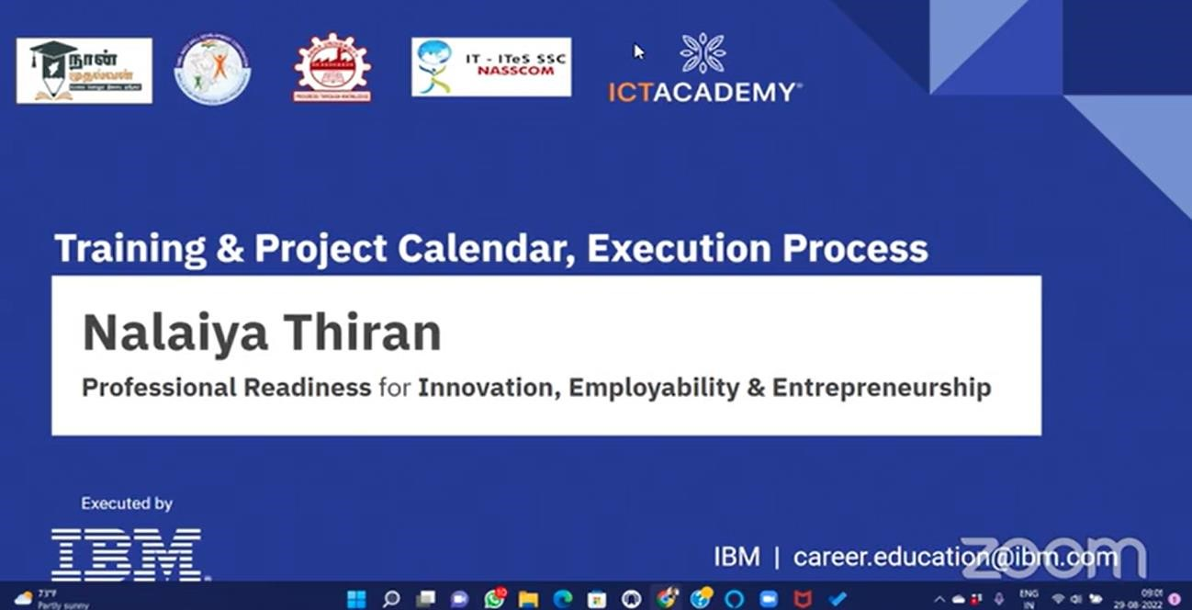

* We did Literature Survey on the selected project and we gathered the related Information. Relevant information on project usecase, referred the existing solutions, technical papers, research publications etc.

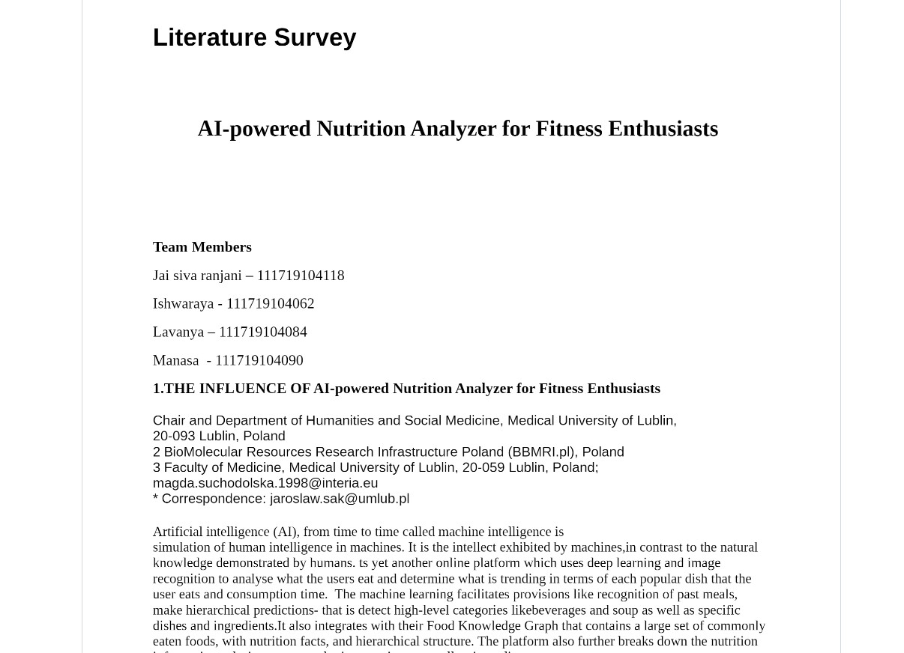

* On **September 1st** our **Technical Training Sessions** started.Our **Day 1**

**Session** was on **September 1st** which was based on the basics of Artificial

Intelligence like the History and Application of AI, Basics of Deep Learning and Machine Learning, Programming Language for AI (Python) and Frameworks of AI.

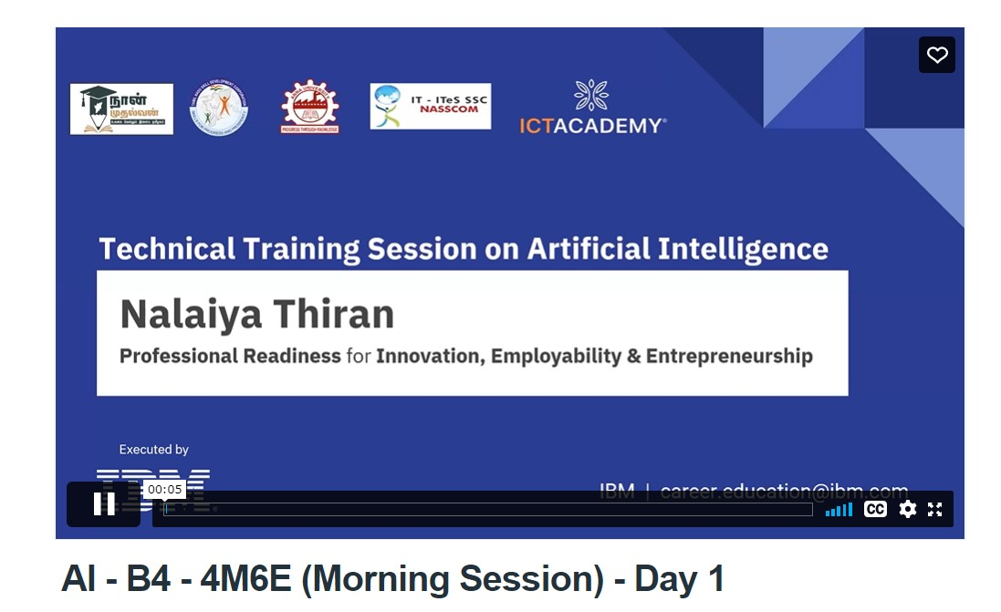

* Our **Day 2 Session** was on **September 3rd** which was a Hands-on session based on basics of python and how to work on Colab.

